A-VIEW 4.0 Server Installation Guide

Amrita e-learning research lab

Amrita e-learning research lab

A-VIEW Server Installation Guide (Importing A-VIEW Server side (Java) into Eclipse)

©Amrita E-learning Research Lab

Website: [www.aview.in](http://www.aview.in)

Phone: 0476.280.4431

Email: [aview@amrita.edu](mailto:aview@amrita.edu)

# Importing A-VIEW Server side Java project into Eclipse

This document explains the steps involved in importing A-VIEW server side (Java) code into eclipse work space.

This document has the following software installed as prerequisites:

1. Eclipse(Indigo)
2. JDK Version 7 or above
3. Tomcat 7.0.41 (preferable)
4. MySQL5.5.16
5. Execute the scripts for creating the aview, aview_audit databases from the aview-mysql-db repository.
6. Then create a database user in mysql – aview_app, give a password that suits you. Then give permission for this user to all databases.

The exact steps are available in the “A-VIEW Server Setup on Windows” document (TODO: put link here).

1. Update the mysql.properties file in the Web project with the password you specified for the aview_app account.

Once the prerequisites are taken care, please follow the below steps to import the project into workspace. Open Eclipse IDE.

1. **From the Eclipse IDE, select *File*and choose *Import.* (Refer Fig: 1)**

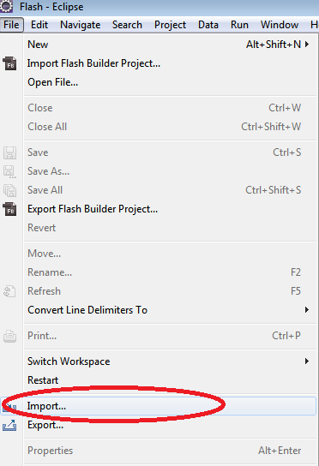

Fig: 1 – Select Import from menu

1. **In the *Import wizard,* select *Existing Projects into Workspace* in *General* and click *Next* Button.**

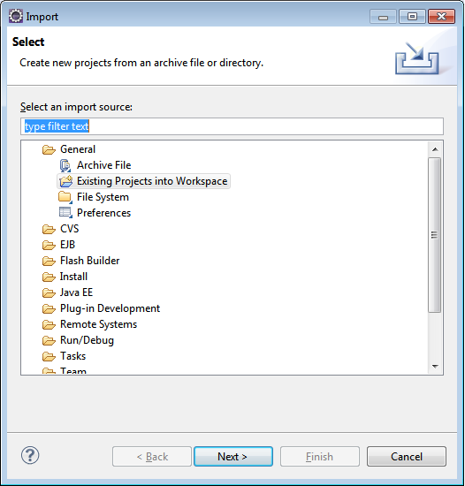

Fig: 2 –Import wizard

1. **Browse the project to be imported.After selecting the project click *Finish* button.**

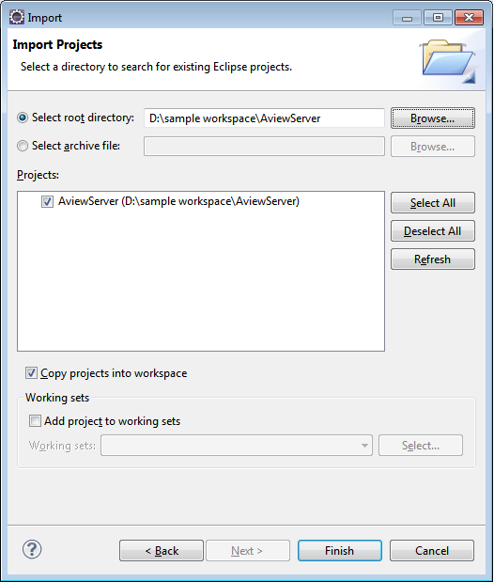

Fig: 3 –Import wizard to select the project

1. **Once the project is imported into the workspace, chances are there for getting compilation errors. If so, there are some setting problems which can be solved by the below steps**

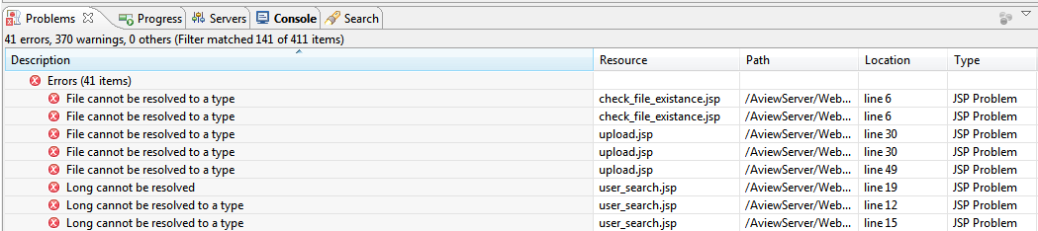

Fig: 4 – Problems view

# To setup JRE

1. **In Eclipse IDE,right click on the project and select Properties, and click *Java Build Path.* Then go to the *Libraries* tab.**

In the list of library you will see JRE System Library as unbounded (If JRE is not set correctly).

(Refer Fig: 5)

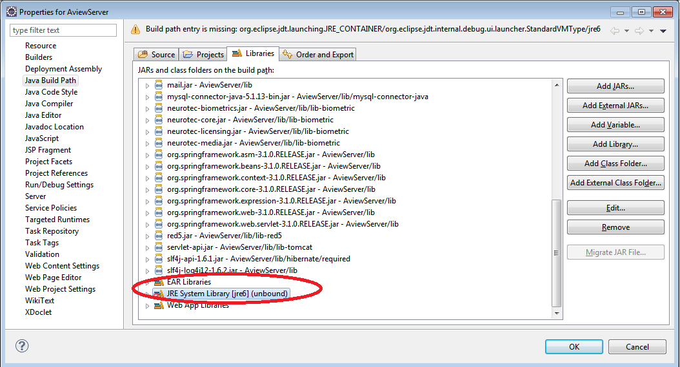

Fig: 5 – Properties

1. **Remove that JRE from the list and click *Add Library* button. (Refer Fig: 6)**

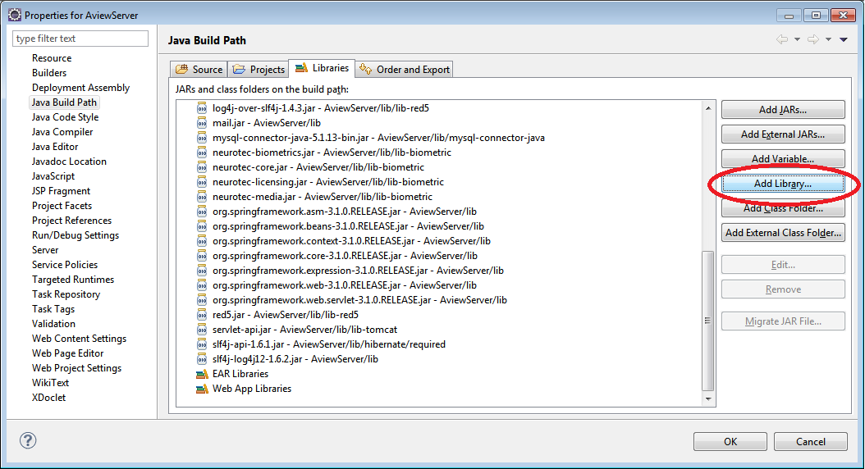

Fig: 6 – Java Build Path

1. **In *Add Library* Wizard, choose *JRE System Library* then click *Next.***

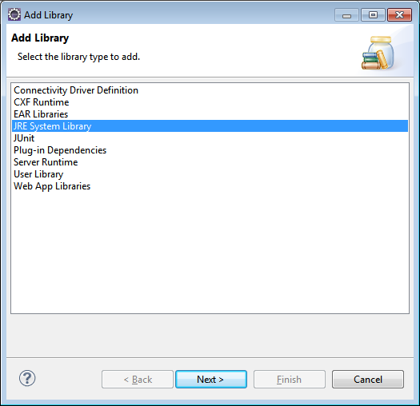

Fig: 7 – Add Library

1. **Select installed JRE and Click *Finish.***

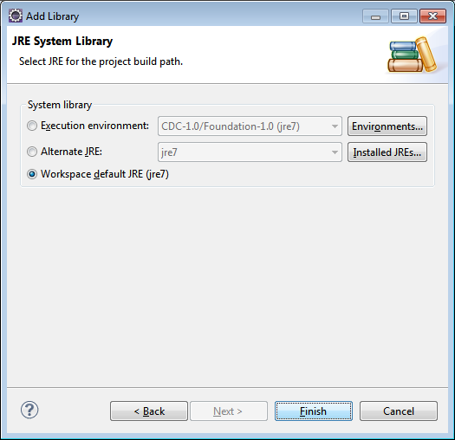

Fig: 8 – Add Library

# Starting A-VIEW server

**Step 1**

In Eclipse, take the ***Servers*** view. Do right click on it and choose ***New***, on choosing ***New*** you will get ***Server***. Click on the ***Server*** to get a new window to create new server. (Refer Fig: 1)

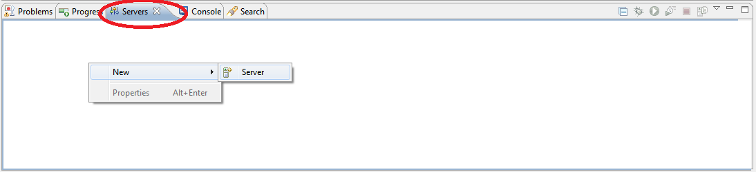

Fig: 9 Starting A-VIEW Server

**Step 2**

Select Tomcat server from ***Apache*** and click ***Next***.

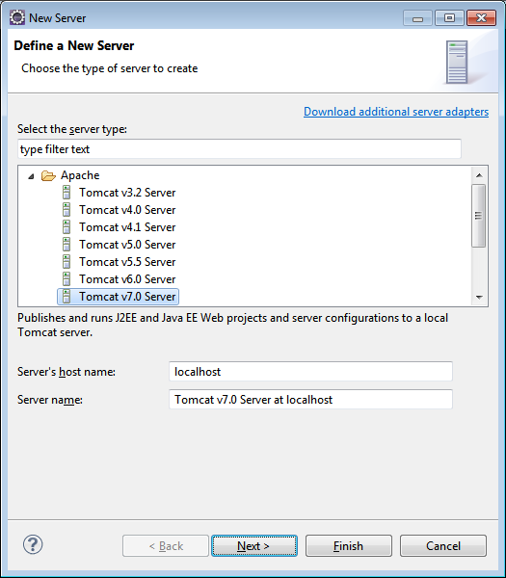

Fig: 10

**Step 3**

Give name to the server (can keep the default).If tomcat is already installed in your machine, provide the tomcat installation directory. Then select your installed JRE and click ***Next***.

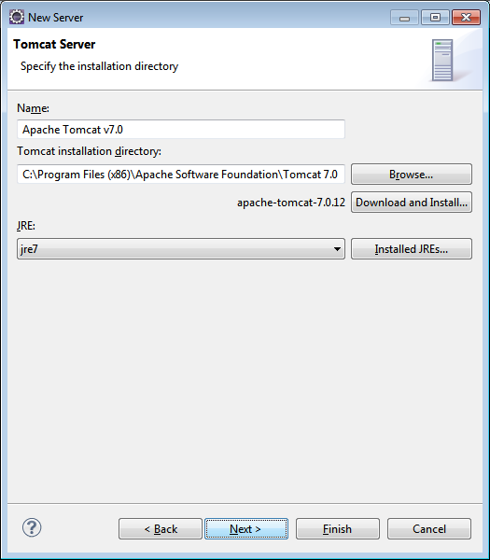

Fig: 11

**Step 4**

Select A-VIEW server from the available list and add it to the configured list. Click ***Next***.

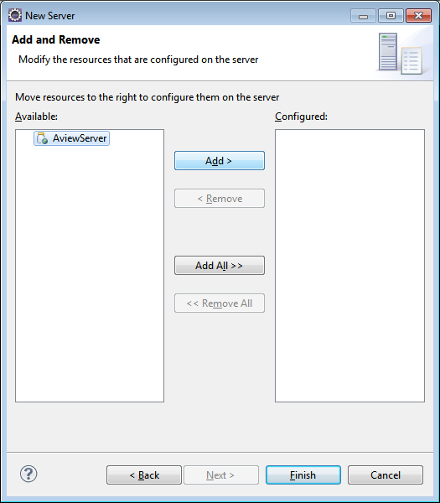

Fig: 12

**Step5**

After adding A-VIEW server to the configured list, click ***Finish***.

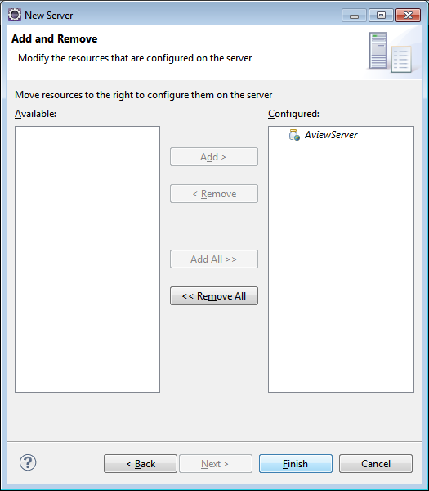

Fig: 13

On clicking ***Finish*** button a new server instance is added. You can see it in the ***Servers*** view.

(Refer Fig: 14)



Fig: 14

**Step 6**

Do right click on the tomcat server instance in the ***Servers*** view and select ***Start.***

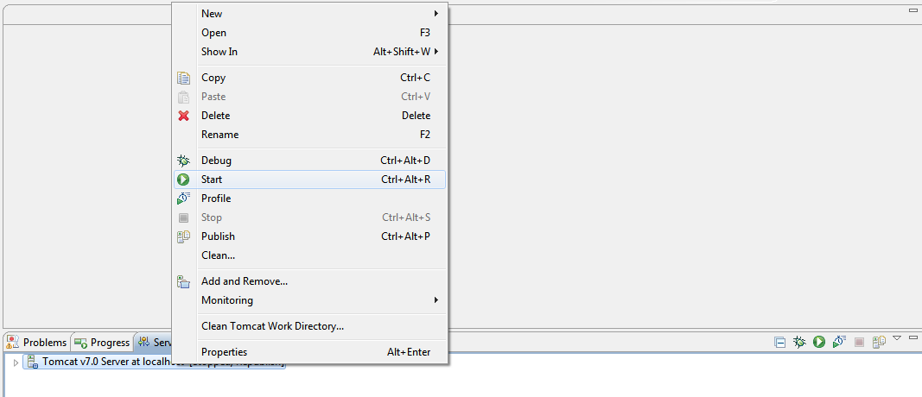

Fig: 15

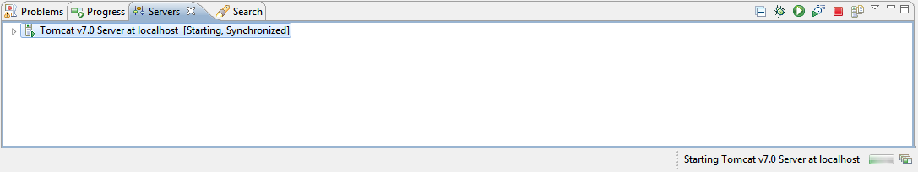

Fig: 16

This time A-VIEW server starts without any previous errors.

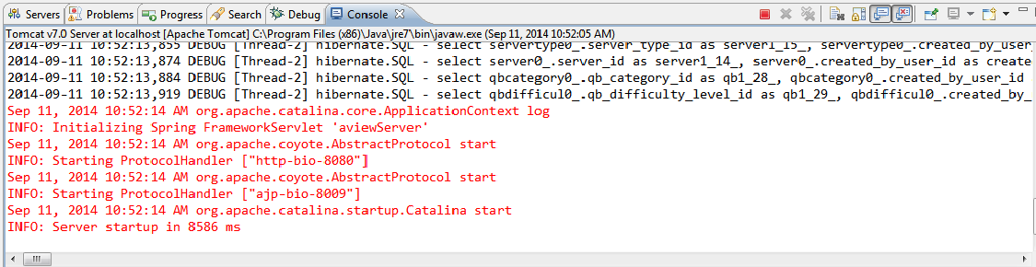

Fig: 17